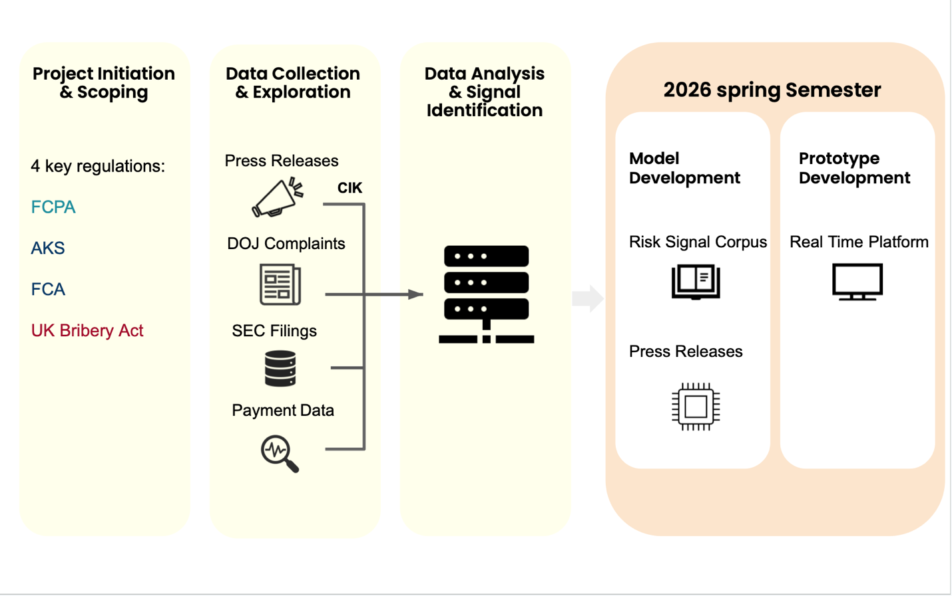
This schema above describes the complete workflow of our capstone project. We are working on building a Proactive Risk Detection Platform for compliance in the pharmaceutical sector. It starts with the initiation and scoping of the project, where we based our work on four major anti-corruption and fraud regulations. Color coding represents the variety of these sources: global regulations like the FCPA (in light blue); US-specific statutes such as the AKS and FCA (in dark blue); and in red, the UK-only Bribery Act. Such variety underlines that our domain expertise must reach across multiple jurisdictions and enforcement environments. Next, we enter the data collection and exploration stage where we collect high-value signals from press releases, DOJ complaints, SEC filings, and payment data unified by Central Index Key (CIK). These serve as inputs to go into the later data-analysis and signal-identification stage to form the basis of early-risk detection. The final stage describes the deliverables for Spring 2026, consisting of model development and a real-time prototype platform. In summary, this schema is important because it shows how we transform scattered public data and cross-jurisdictional regulations into a coherent, actionable compliance-risk intelligence system.

